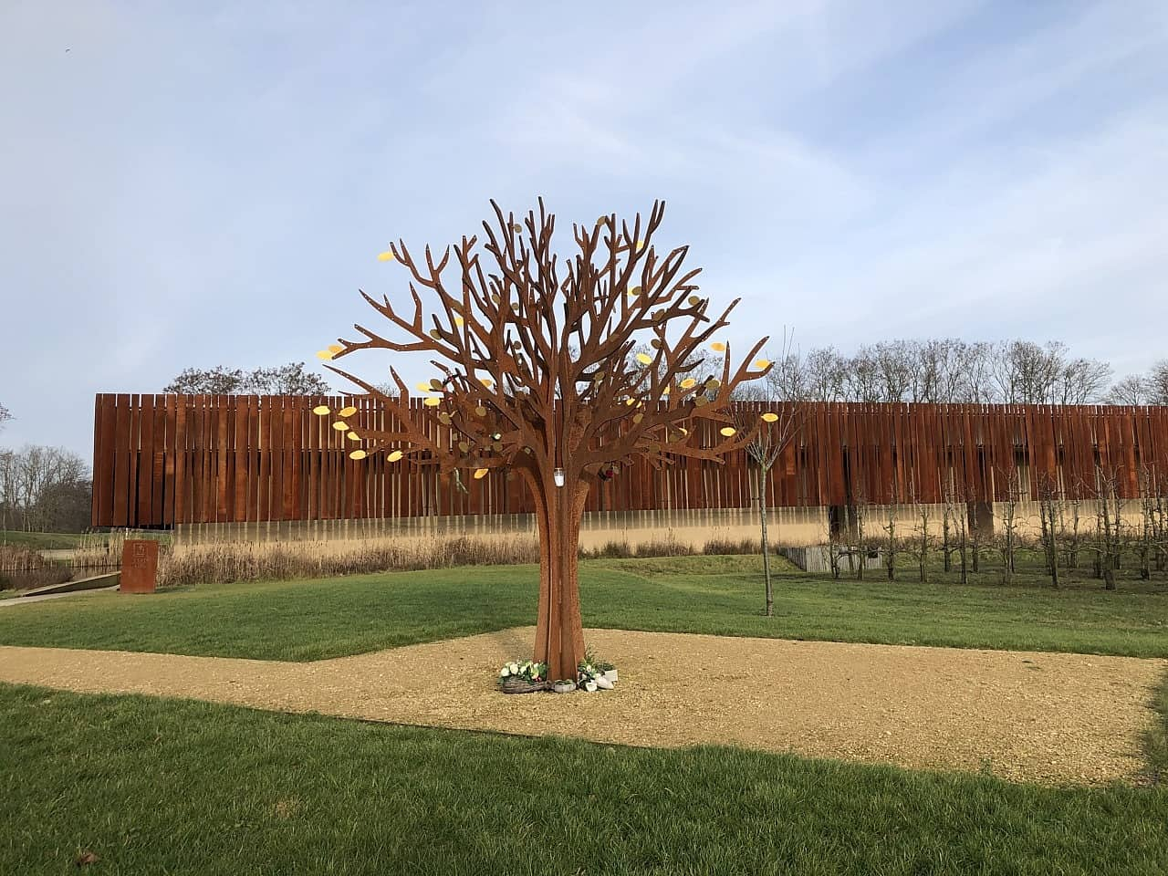
Memorial Leaf Application Form

Leaves can be purchased for the memorial tree that sits within the crematorium. Your loved ones name can be engraved on a vibrant golden coloured memorial leaf and placed on the crematorium memorial tree.
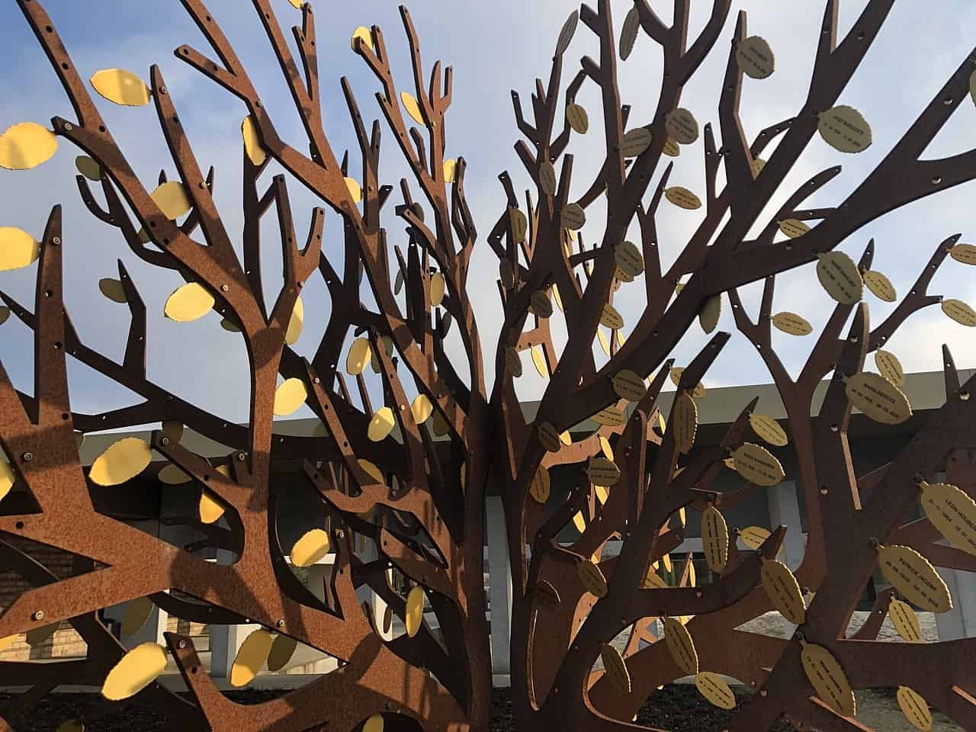

Leaves can be double sided with your loved ones name, date of birth and date of death on one side and an optional short inscription on the reverse.

Applicant Details

Applicant Name
Applicant Address
Applicant Phone Number
You will be contacted for payment

Deceased Details

Name of Deceased
Date of Death

Order Confirmation

Applicant Signature

Date

Internal Use Only

CREMATION NO. | RECEIPT NO | ORDERED | RECEIVED | NOTIFIED | MEMORIAL TYPE | MEMORIAL REF

Leaf Inscription

Name of Deceased
Date of Birth
Date of Death

Optional Reverse Inscription – maximum 39 characters

The Joint Committee reserve the right to vary any inscriptions as may be found necessary or to refuse an entry which is considered unsuitable.

